APPENDIX 1: RESEARCH QUESTIONNAIRES
THE SITUATION OF MUSCULOSKELETAL DISORDERS AND RELATED FACTORS AMONG HANOI URBAN ENVIRONMENT WORKERS IN 2017
Code | Questions | Response
A. GENERAL INFORMATION ABOUT THE WASTE COLLECTORS
A1 | Year of Birth (calendar) | Year: ………
A2 | Sex | 1. Male
A2 | Sex | 2. Female
A3 | Education level | 1. Primary school  2. High school  3. Senior high school  4. Vocational school  5. College and above  6. Other (state):...................
A4 | How old were you when you started working at your current position? | ………. years old
B. WORKING CONDITIONS
WORK ORGANIZATION
B1 | On average, how many hours do you work per shift? | ..................... hours
B2 | In the past 3 months, what was your assignment? | - Shift 1  - Shift 2  - Shift 3  - Frequently change
EXPOSURE TO PHYSICAL OCCUPATIONAL HAZARDS
B3 | What is your level of exposure to hot working environment? | 1. Frequently  2. Low /seasonal exposure  3. No exposure
B4 | What is your level of exposure to sunlight at work? | 1. Frequently  2. Low /seasonal exposure  3. No exposure
B5 | What is your level of exposure to cold working environment? | 1. Frequently  2. Low /seasonal exposure  3. No exposure
B6 | What is your level of exposure to wet working conditions? | 1. Frequently  2. Low /seasonal exposure  3. No exposure
WORK POSTURES (SEE THE ILLUSTRATION)
B7 | In your shift, how many hours do you work in the posture with The hand raised above the head, or elbow above the shoulder? | - ≥ 4 hours  - ≥ 3 hours  - ≥ 2 hours  - < 2 hours  - Not perform
B8 | In your shift, how many hours do you work in the posture with The neck bent for a prolonged duration at an angle of over 45º without supportive equipment? | - ≥ 4 hours  - ≥ 3 hours  - ≥ 2 hours  - < 2 hours  - Not perform
B9 | In your shift, how many hours do you work in the posture with The back bent at an angle of over 30º without supportive equipment for a prolonged duration? | - ≥ 4 hours  - ≥ 3 hours  - ≥ 2 hours  - < 2 hours  - Not perform
B10 | In your shift, how many hours do you work in the posture with The back bent at an angle of over 45º without supportive equipment for a prolonged duration? | - ≥ 4 hours  - ≥ 3 hours  - ≥ 2 hours  - < 2 hours  - Not perform
B11 | In your shift, how many hours do you work in the Squatting posture? | - ≥ 4 hours  - ≥ 3 hours  - ≥ 2 hours  - < 2 hours  - Not perform
B12 | In your shift, how many hours do you work in the Kneeling posture? | - ≥ 4 hours  - ≥ 3 hours  - ≥ 2 hours  - < 2 hours  - Not perform
B13 | In your shift, how many hours do you work in the posture of Medial rotation while walking? | - ≥ 4 hours  - ≥ 3 hours  - ≥ 2 hours  - < 2 hours  - Not perform
B14 | In your shift, how many hours do you work in the posture of Thoracolumbar flexion? | - ≥ 4 hours  - ≥ 3 hours  - ≥ 2 hours  - < 2 hours  - Not perform
B15 | In your shift, how many hours do you have to carry >5 kg with one hand? | - ≥ 4 hours  - ≥ 3 hours  - ≥ 2 hours  - < 2 hours  - Not perform
B16 | In your shift, how many hours do you have to frequently lift >5 kg (more than twice per minute)? | - ≥ 4 hours  - ≥ 3 hours  - ≥ 2 hours  - < 2 hours  - Not perform
B17 | In your shift, how many hours do you have to lift >37.5 kg once/day or >27.5 kg 10 times/day | - ≥ 4 hours  - ≥ 3 hours  - ≥ 2 hours  - < 2 hours  - Not perform
B18 | In your shift, how many hours do you have to lift >13.5 kg from the height of above the shoulder, below the knee or the distance of one arm more than 25 times/day? | - ≥ 4 hours  - ≥ 3 hours  - ≥ 2 hours  - < 2 hours  - Not perform
PSYCHOLOGICAL STRESS
B19 | What is your level of anxiety and frustration during the last week? | - Completely comfortable / Not anxious  - Mid anxious but acceptable  - Anxious  - Very anxious
B20 | What is your level of stress during the last week? | - Completely comfortable / Not stressful  - Mid stressful but acceptable  - Stressful  - Very stressful
B21 | What is your level of satisfaction with work during the last week? | - Absolutely satisfied  - Satisfied  - Normal  - Not satisfied
B22 | What is your level of exposure to threat of psychological violence? | - Frequently  - Occasionally  - Never / no exposure
B23 | What is your level of exposure to threat of physical violence? | - Frequently  - Occasionally  - Never / no exposure

ILLUSTRATION OF WORKING POSTURES
1. The hand raised above the head, or elbow above the shoulder | 2. The neck bent for a prolonged duration at an angle of over 45º without supportive equipment | 3. The back bent at an angle of over 30º without supportive equipment for a prolonged duration | 4. The back bent at an angle of over 45º without supportive equipment for a prolonged duration
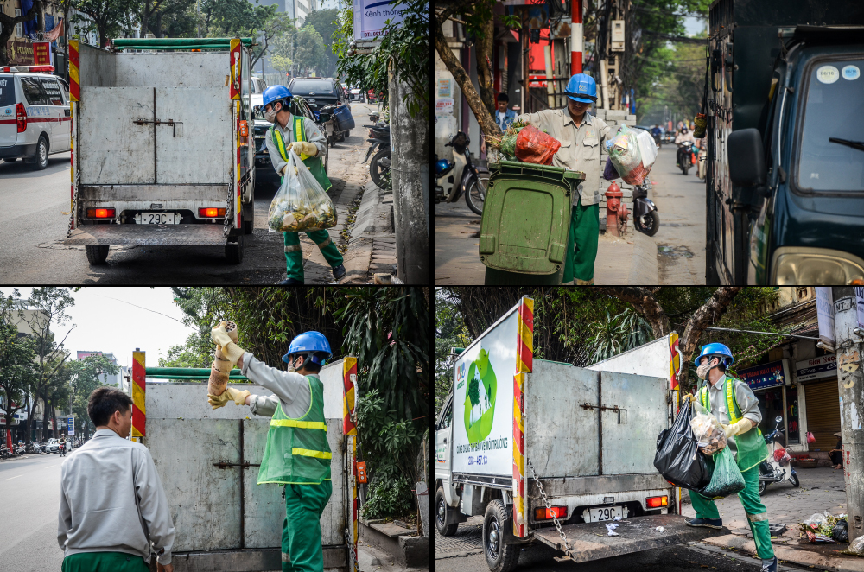 | 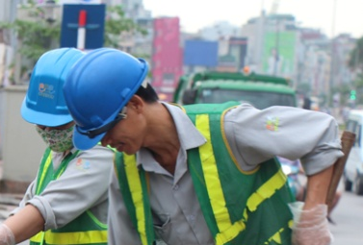 | 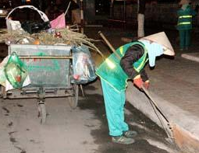 | 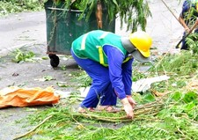
5. Squatting | 6. Kneeling | 7. Medial rotation while walking | 8. Thoracolumbar flexsion
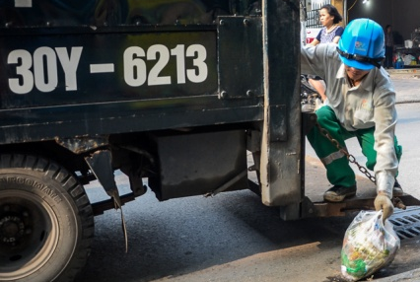 | 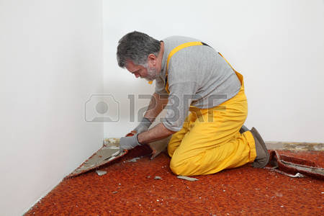 | 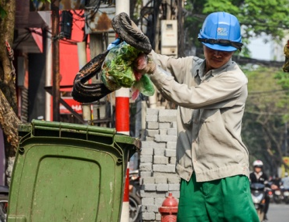 | 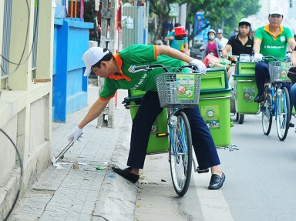
9. Carrying >5 kg with one hand | 10. Lifting >5 kg more than twice per minute | 11. Lifting >37.5 kg once/day or >27.5 kg 10 times/day | 12. Lifting >13.5 kg from the height of above the shoulder, below the knee or the distance of one arm more than 25 times/day
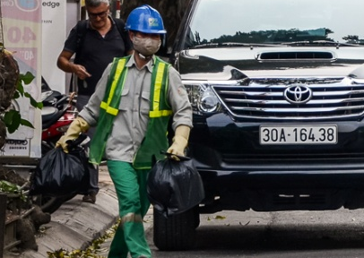 |  | 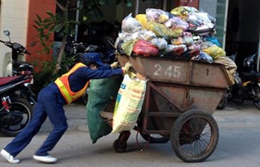 | 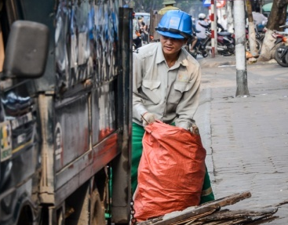

Örebro Musculoskeletal Pain Questionnaire (ÖMPQ) Linton and Boersma 2003

These questions and statements apply if you have aches or pains, such as back, shoulder or neck pain. Please read and answer questions carefully. Do not take long to answer the questions, however it is important that you answer every question. There is always a response for your particular situation.
5. Where do you have pain? Place a tick (√) for all appropriate sites.  □Neck □Shoulder □Arm  □Lower Back □Leg □Other (state)  □Upper Back |  |  | 2x (max 10)
6. How many days of work have you missed because of pain during the past 18 months? Tick (√) one.
□0 days (1) □1-2 days (2) □3-7 days (3) □8-14 days (4)
□15-30 days (5) □1 month (6) □2 months (7)
□3-6 months (8) □6-12 months (9) □over 1 year (10)
7. How long have you had your current pain problem? Tick (√) one.
□0-1 week (1) □1-2 weeks (2) □3-4 weeks (3) □4-5 weeks (4)
□6-8 weeks (5) □9-11 weeks (6) □3-6 months (7) □6-9 months (8)
□9-12 months (9) □over 1 year (10)
8. Is your work heavy or monotonous? Circle the best alternative.  0 1 2 3 4 5 6 7 8  Not at all | 9 | 10  Extremely
9. How would you rate the pain that you have had during the past week? Circle one.
0 1 2 3 4 5 6 7 8 9 10
No pain Pain as bad as it could be
10. In the past three months, on average, how bad was your pain on a 0-10 scale? Circle one.
0 1 2 3 4 5 6 7 8 9 10
No pain Pain as bad as it could be
11. How often would you say that you have experience pain episodes, on average, during the past three months? Circle one.
0 1 2 3 4 5 6 7 8 9 10
Never Always
12. Based on all things you do to cope, or deal with your pain, on an average day, how much are you able to decrease it? Circle the appropriate number.  0 1 2 3 4 5 6 7 8 9 10  Can’t decrease it at all Can decrease it completely |  |  | 10 - x
13. How tense or anxious have you felt in the past week? Circle one.
0 1 2 3 4 5 6 7 8 9 10
Absolutely calm and relaxed As tense and anxious as I’ve ever felt
14. How much have you been bothered by feeling depressed in the past week? Circle one.
0 1 2 3 4 5 6 7 8 9 10
Not at all Extremely
15. In your view, how large is the risk that your current pain may become persistent? Circle one.
0 1 2 3 4 5 6 7 8 9 10
No risk Very large risk
16. In your estimation, what are the chances that you will be able to work in six months? Circle one.  0 1 2 3 4 5 6 7 8 9 10  No chance Very large chance |  |  | 10 - x
17. If you take into consideration your work routines, management, salary, promotion possibilities and work mates, how satisfied are you with your job? Circle one.  0 1 2 3 4 5 6 7 8 9 10  Not satisfied at all Completely satisfied |  |  | 10 - x
Here are some of the things that other people have told us about their pain. For each statement, circle one number from 0 to 10 to say how much physical activities, such as bending, lifting, walking or driving, would affect your pain.
18. Physical activity makes my pain worse.
0 1 2 3 4 5 6 7 8 9 10
Completely disagree Completely agree
19. An increase in pain is an indication that I should stop what I’m doing until the pain decreases.
0 1 2 3 4 5 6 7 8 9 10
Completely disagree Completely agree
20. I should not do my normal work with my present pain.
0 1 2 3 4 5 6 7 8 9 10
Completely disagree Completely agree
Here is a list of five activities. Circle the one number that best describes your current ability to participate in each of these activities.
21. I can do light work for an hour.  0 1 2 3 4 5 6 7 8 9 10  Can’t do it because of pain problem Can do it without pain being a problem |  |  | 10 - x
22. I can walk for an hour.  0 1 2 3 4 5 6 7 8 9 10  Can’t do it because of pain problem Can do it without pain being a problem |  |  | 10 - x
23. I can do ordinary household chores.  0 1 2 3 4 5 6 7 8 9 10  Can’t do it because of pain problem Can do it without pain being a problem |  |  | 10 - x
24. I can do the weekly shopping.  0 1 2 3 4 5 6 7 8 9 10  Can’t do it because of pain problem Can do it without pain being a problem |  |  | 10 - x
25. I can sleep at night.  0 1 2 3 4 5 6 7 8 9 10  Can’t do it because of pain problem Can do it without pain being a problem |  |  | 10 - x

Thank you for your cooperation!

